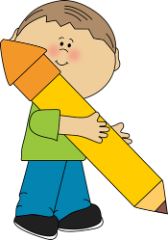
Language Arts – Grade 2
Term 3
Ms. Lebbon
Big Ideas
Stories and other texts connect us to ourselves, our families, and our communities.
Language and story can be a source of creativity and joy.

Through listening and speaking, we connect with others and share our world.
Everyone has a unique story to share.

Curiosity and wonder lead us to new discoveries about ourselves and the world around us.
Playing with language helps us discover how language works.

Curricular Competencies
Using oral, written, visual, and digital texts, students are expected individually and collaboratively to be able to:
Comprehend and Connect
- Read fluently at grade level.
- Use sources of information and prior knowledge to make meaning.
- Use developmentally appropriate reading, listening, and viewing strategies to make meaning.
- Engage actively as listeners, viewers, and readers, as appropriate, to develop understanding of self, identity, and community.
- Demonstrate awareness of the role that story plays in personal, family, and community identity.
- Use personal experience and knowledge to connect to stories and other texts to make meaning.
- Recognize the structures and elements of story.
- Show awareness of how story in First Peoples' cultures connects people to family and community.
Create and Communicate
- Exchange ideas and perspectives to build shared understanding.
- Create stories and other texts to deepen awareness of self, family, and community.
- Plan and create a variety of communication forms for different purposes and audiences.
- Communicate using sentences and most conventions of Canadian spelling, grammar, and punctuation.
- Explore oral storytelling processes.
Content Learning Standards
Students will be expected to know the following "I Can" statements:

Reading
- I can read at grade level (PM Benchmark level 21-22)
- I can identify literary elements and devices (e.g. poetic language, figurative language, sound play, images, colour, and basic symbols)
- I can continue to use reading strategies to help me decode words (e.g. blends, word families, vowel sounds, word chunking, and visual clues)
- I can identify all the grade two sight words
- I can use a variety of reading strategies to help me read and understand stories independently
- I can make connections, ask questions, and visualize images to stories
- I can read fluently
- I can self-correct my reading errors consistently
- I can talk about my thinking and reflect on my learning
- I can listen/view stories in First Peoples' cultures to connect to family and community

Writing
- I can print neatly with the appropriate letter formation
- I can print sentences using proper spacing between words
- I can write many sentences that include details and descriptions
- I can include compound sentences in my writing (e.g. using connecting words such as "because", "and", or "but")
- I can use my knowledge of digraphs, blends, and phonetic rules (e.g. "When two vowels are a walking, the first one does the talking.") to sound out words to spell
- I can consistently begin my sentences, names, and the pronoun "I" with an uppercase letter
- I can consistently complete my sentences with a period, question mark, or exclamation mark
- I can spell many high frequency words
- I can continue to use basic writing processes by revising, editing, and proofreading my work
- I can use class-generated criteria to assess my own and others' work

Oral Language
- I can take turns speaking
- I can ask questions to clarify
- I can speak with the appropriate tone, volume, inflection, and pace
- I can express simple opinions
- I can participate in classroom discussions

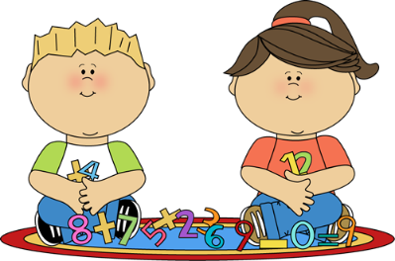
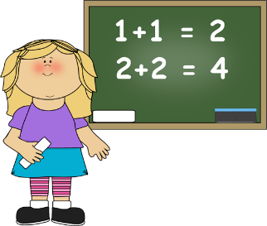
Math – Grade 2
Term 3
Ms. Lebbon
Big Ideas
Objects and shapes have attributes that can be described, measured, and compared.
Concrete items can be represented, compared, and interpreted pictorially and in graphs.

Curricular Competencies
Students are expected to be able to do the following:
Reasoning and Analyzing
- Use reasoning to explore and make connections
- Estimate reasonably
- Develop mental-math strategies and abilities to make sense of quantities
- Use technology to explore mathematics
- Model mathematics in contextualized experiences
Understanding and Solving
- Develop, demonstrate, and apply mathematical understanding through play, inquiry, and problem solving
- Visualize to explore mathematical concepts
- Develop and use multiple strategies to engage in problem solving
- Engage in problem-solving experiences that are connected to place, story, cultural practices, and perspectives relevant to local First Peoples communities, the local community, and other cultures
Communicating and Representing
- Communicate mathematical thinking in many ways
- Use mathematical vocabulary and language to contribute to mathematical discussions
- Explain and justify mathematical ideas and decisions
- Represent mathematical ideas in concrete, pictorial, and symbolic forms
Connecting and Reflecting
- Reflect on mathematical thinking
- Connect mathematical concepts to each other and to other areas and personal interests
- Incorporate First Peoples worldviews and perspectives to make connections to mathematical concepts

Content Learning Standards
Students will be expected to know the following "I Can" statements:

Direct Linear Measurement
- I can use centimetres and metres to measure objects
- I can reasonably estimate the length of an object
- I can measure and record length, height, and width, using standard units

Addition and Subtraction to 100
- I can decompose numbers to 100
- I can estimate sums and differences to 100
- I can use strategies such as looking for multiples of 10, friendly numbers (e.g. 48+37 is the same as 37=35+2, 48+2; therefore 50+35=85), decomposing into 10s and 1s and recomposing (e.g. 48+37 is the same as 40+30=70, 8+7=15; therefore 70+15=85), and compensating (e.g. 48+37 is the same as 48+2=50, 37-2+35; therefore 50+35=85)
- I can use adding up to find the difference
- I can use an open number line, hundred chart, and ten-frame
- I can use addition and subtraction in real-life context and problem-based situations

Pictorial Representation of Concrete Graphs
- I can collect data to create a concrete graph
- I can represent a graph, using pictorial representation through grid, stamps, or drawings
- I can understand the one-to-one correspondence in graphs

Likelihood of Familiar Life Events
- I can use the proper vocabulary to describe probability (e.g. certain, uncertain, more, less, or equally likely)

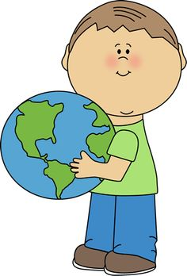
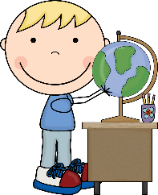
Social Studies – Grade 2
Term 3
Ms. Lebbon
Big Ideas
Canada is made up of diverse regions and communities.

Curricular Competencies
Students are expected to be able to do the following:

- Use Social Studies inquiry processes and skills to: ask questions; gather, interpret, and analyze ideas; and communicate findings and decisions
- Explain why people, events, or places are significant to various individuals and groups
- Ask questions, make inferences, and draw conclusions about the content and features of different types of sources
- Sequence objects, images, and events, or explain why some aspects change and what has stayed the same
- Recognize causes and consequences of an event, decisions, and development
- Explain why people's beliefs, values, worldviews, experiences, and roles give them different perspectives on people, places, issues, or events
- Make value judgements about events, decisions, or action, and suggest lessons that can be learned

Content Learning Standards
Students will be expected to know the following "I Can" statements:
- I can describe daily life in different communities (e.g. work, housing, use of land, education, and transportation)
- I can describe key cultural aspects of different cultures (e.g. language, traditions, arts, and food)
- I can identify cultural diversity within my community
- I can explain how people acquire goods and services (e.g. by buying or renting, or through public funding)
- I can describe the needs and wants in different communities
- I can identify different goods and services based on the size of a community
- I can understand the differences between psychological and physical needs and wants
- I can describe the diverse features of the environment in other parts of Canada and the world (e.g. climate zones, landforms, bodies of water, plants and animals)

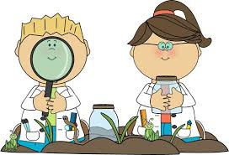
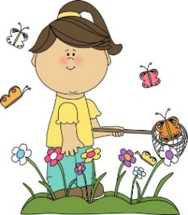
Science – Grade 2
Term 3
Ms. Lebbon
Big Ideas
Water is essential to all living things, and it cycles through the environment.

Curricular Competencies
Students are expected to be able to do the following:
Questioning and Predicting
- Demonstrate curiosity and a sense of wonder about the world
- Observe objects and events in familiar contexts
- Ask questions about familiar objects and events
- Make simple predictions about familiar objects and events
Planning and Conducting
- Make and record observations
- Safely manipulate materials to test ideas and predictions
- Make and record simple measurements using informal and non-standard methods
Processing and Analyzing Data and Information
- Experience and interpret the local environment
- Sort and classify data and information using drawings, pictographs, and provided tables
- Compare observations with predictions through discussion
- Identify simple patterns and connections
Evaluating
- Compare observations with those of others
- Consider some environmental consequences of their actions
Applying and Innovating
- Take part in caring for self, family, classroom, and school through personal approaches
- Transfer and apply learning to new situations
- Generate and introduce new or refined ideas when problem solving
Communication
- Communicate observations and ideas using oral or written language, drawing, or role-play
- Express and reflect on personal experiences of place

Content Learning Standards
Students will be expected to know the following "I Can" statements:
- I can understand water is a limited resource, and that it is not being replaced at the same rate as it is being used
- I can identify water sources (e.g. oceans, lakes, rivers, wells, springs, etc.)
- I can identify the majority of fresh water is stored underground and in glaciers
- I can explain the water cycle, and use the proper vocabulary to describe the processes involved (e.g. evaporation, condensation, precipitation, and runoff)
- I can understand the water cycle is a major component of weather (e.g. precipitation, clouds)

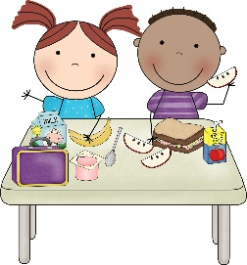
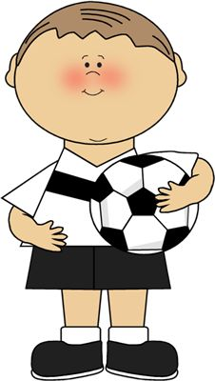
Physical and Health Education – Grade 2
Term 3
Ms. Lebbon
Big Ideas
Learning how to participate and move our bodies in different physical activities helps us develop physical literacy.
Daily participation in physical activity at a moderate to vigorous intensity levels benefits all aspects of our well-being.

Having good communication skills and managing our emotions enables us to develop and maintain healthy relationships.
Adopting healthy personal practices and safety strategies protects ourselves and others.

Our physical, emotional, and mental health are interconnected.

Curricular Competencies

Students are expected to be able to do the following:
Physical Literacy
- Develop and demonstrate a variety of fundamental movement skills in a variety of physical activities and environments
- Apply methods of monitoring exertion levels in physical activity
- Develop and demonstrate safety, fair play, and leadership in physical activities
- Identify and explain factors that contribute to positive experiences in different physical activities
Healthy and Active Living
- Participate daily in physical activity at moderate to vigorous intensity levels
- Identify and describe opportunities to be physically active at school, at home, and in the community
- Explore strategies for making healthy eating choices
- Describe ways to access information on and support services for a variety of health topics
- Explore and describe components of healthy living
Social and Community Health
- Identify and describe avoidance or assertiveness strategies to use in unsafe and/or uncomfortable situations
- Develop and demonstrate respectful behaviour when participating in activities with others
- Identify and describe characteristics of positive relationships
- Explain how participation in outdoor activities support connections with the community and environment

Mental Well-Being
- Identify and apply strategies that promote mental well-being
- Identify and describe feelings and worries, and strategies for dealing with them
- Identify personal skills, interests, and preferences and describe how they influence self-identity

Content Learning Standards
Students will be expected to know the following "I Can" statements:

- I can participate in different types of physical activity (individual, dual, and game activities)
- I can regularly meet the Daily Physical Activity requirement
- I can move safely in different environments
- I can play fairly in physical activities
- I can participate in rhythmic activities, such as gymnastics and dance
- I can identify the effects of different activities on the body (e.g. increased breathing, sweating, elevated heart rate)
- I can use strategies and skills to use in potentially hazardous, unsafe, or abusive situations (e.g. calling out for help and getting away, using a strong voice to say "no", telling a trusted adult until you get help)
- I can understand I am not to give out personal information to strangers or on the internet
- I can describe the effects of different substances (e.g. poisons, medications, psychoactive substances) and strategies for preventing personal harm

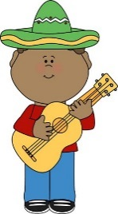
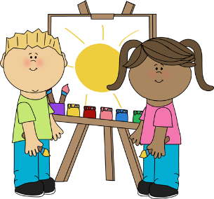
Arts Education– Grade 2
Term 3
Ms. Lebbon
Big Ideas
Inquiry through the arts creates opportunities for risk taking.
Creative expression develops our unique identity and voice.

People connect to the hearts and minds of others in a variety of places and times through the arts.
Dance, drama, music, and visual arts are each unique languages for creating and communicating.

Curricular Competencies
Students are expected to be able to do the following:
Exploring and Creating
- Explore elements, processes, materials, movements, technologies, tools, and techniques of the arts
- Create artistic works collaboratively and as an individual, using ideas inspired by imagination, inquiry, experimentation, and purposeful play
- Explore personal experience, community, and culture through arts activities
Reasoning and Reflecting
- Observe and share how artists (dancers, actors, musicians, and visual artists) use processes, materials, movements, technologies, tools, and techniques
- Develop processes and technical skills in a variety of art forms to refine artistic abilities
- Reflect on creative processes and make connections to other experiences
Communicating and Documenting
- Interpret symbolism and how they can be used to express meaning through the arts
- Express feelings, ideas, stories, observations, and experiences through the creative works
- Describe and respond to works of art
- Experience, document, perform, and share creative works in a variety of ways
- Demonstrate increasingly sophisticated application and/or engagement of curricular content
Content Learning Standards
Students will be expected to know the following "I Can" statements:
- I can, in dance, explore body, space, dynamics, time, and relationships
- I can be responsible when engaging with others in dance
- I can participate in traditional and contemporary Aboriginal arts and arts-making processes
- I can appreciate a variety of local works of art and artistic traditions
- I can participate in music class exploring beat, rhythm, tempo, pitch, dynamics, form, and texture
Career Education – Grade 2
Term 3
Ms. Lebbon
Big Ideas
Strong communities are the result of being connected to family and community and working together toward common goals.
Confidence develops through the process of self-discovery.

Everything we learn helps us to develop skills.
Effective collaboration relies on clear, respectful communication.

Learning is a lifelong enterprise.
Communities include many different roles requiring many different skills.

Curricular Competencies
Students are expected to be able to do the following:
- Identify and appreciate their personal attributes, skills, interests, and accomplishments
- Recognize the importance of positive relationships in their lives
- Share ideas, information, personal feelings, and knowledge with others
- Work respectively and constructively with others to achieve common goals
- Recognize the importance of learning in their lives and future careers
- Set and achieve realistic learning goals for themselves
- Identify and appreciate the roles and responsibilities of people in their schools, families, and communities
- Demonstrate effective work habits and organizational skills appropriate to their level of development
- Recognize the basic skills required in a variety of jobs in the community
Content Learning Standards
Students will be expected to know the following "I Can" statements:
- I can work respectively and constructively with others to achieve a common goal
- I can continue to demonstrate effective work habits and organizational skills
- I can share ideas, information, personal feelings, and knowledge with others
- I can work on self-regulation strategies

